**Assignment 2**

Part 1: Basic Queries with Select

Query 1:

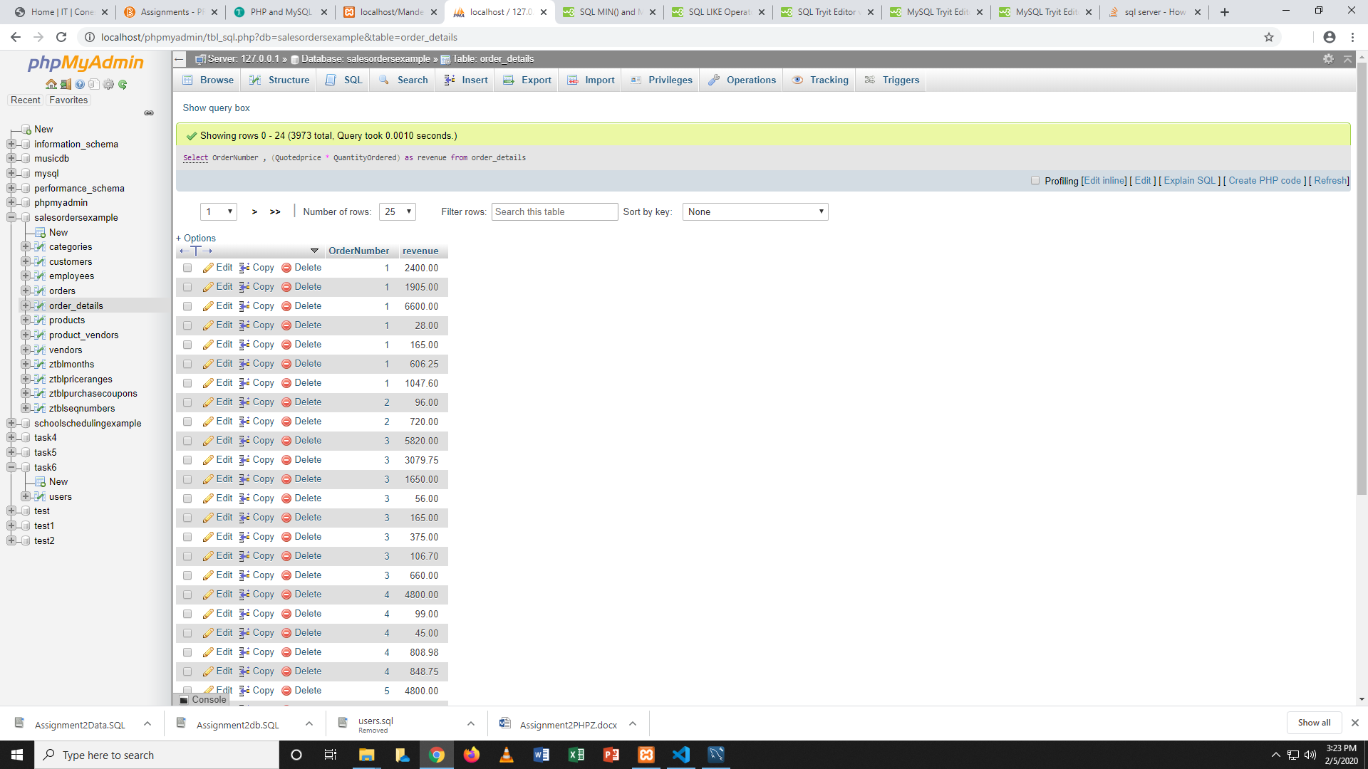

Query 2:

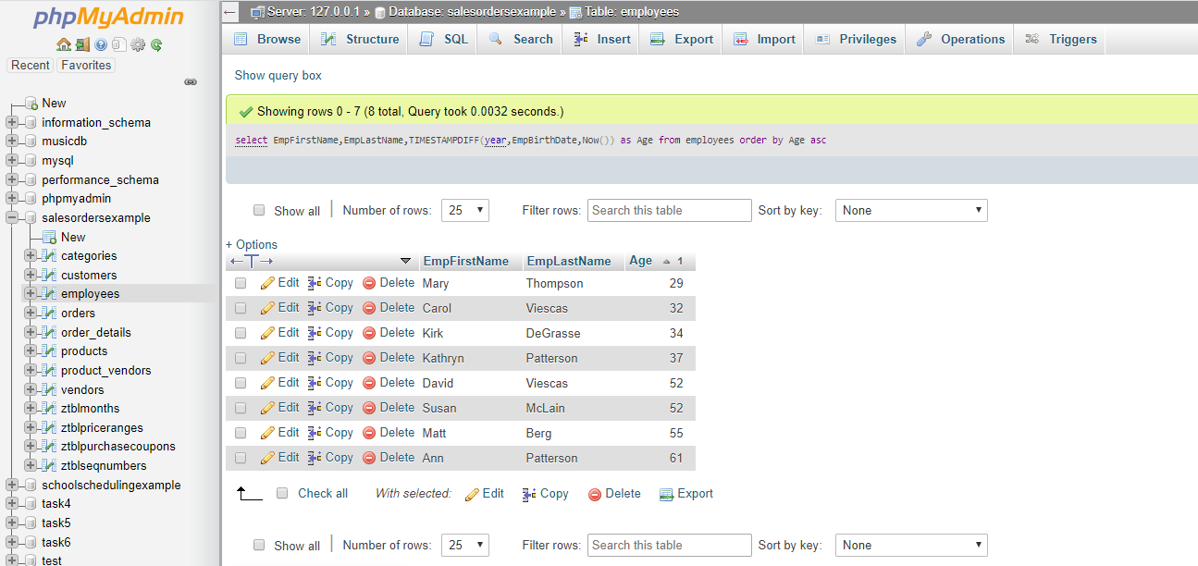

Part 2: Conditional Queries

Query 1:

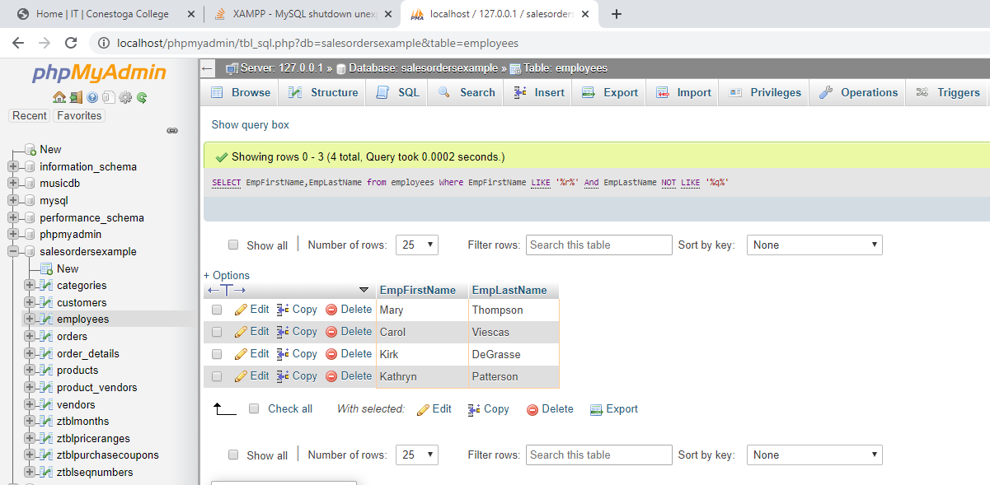

Part 4: Joins

Query 1:

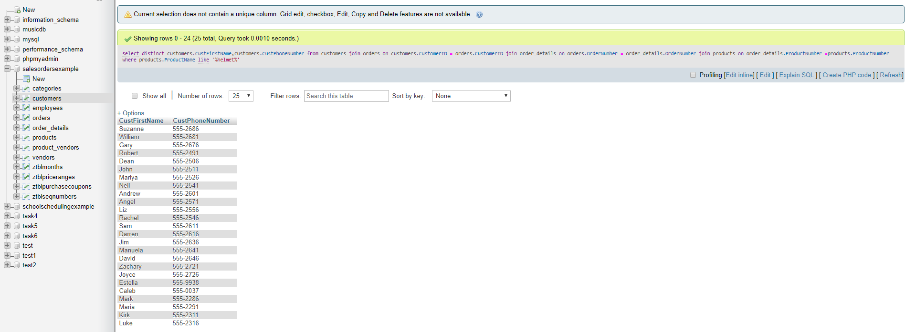

Query 2:

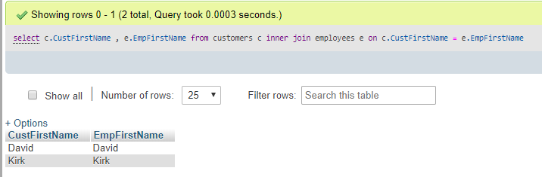

Part 5: Aggregate Functions

Query 1:

